Paddy Borthwick Paper Road Pinot Noir.
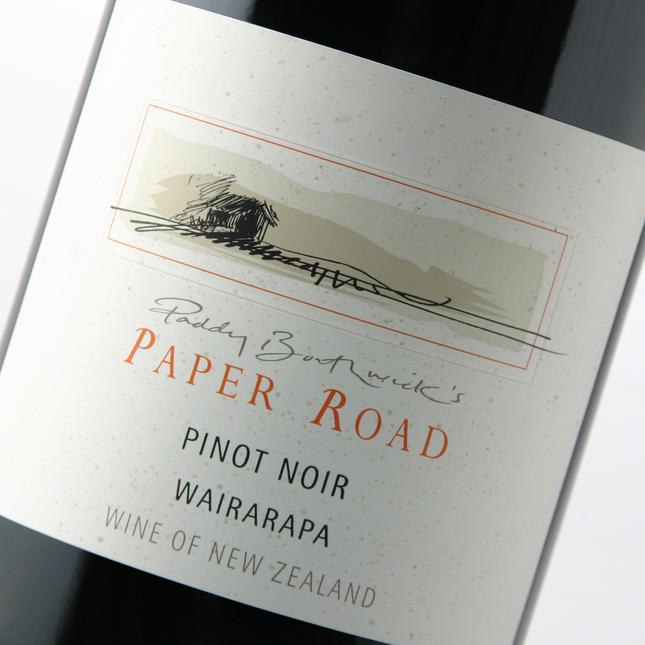
Winery: Borthwick Vineyard
Region: Gladstone, Wairarapa
Grapes: Pinot Noir
Vintner: Paddy Borthwick
History: Original survey documents describe a road which was to run through the Estate family vineyard. Happily the Paper Road was never formed, and instead, gives its name to this individual range of wines.
Established in 1996 the family owned and managed Borthwick Vineyard perfectly captures the special region of Gladstone, New Zealand. Sustainably practices and minimal intervention in the vineyard and winery gives our wines their distinctive single vineyard characteristics and flavor.
Vineyard Location: Gladstone, Wairarapa, New Zealand. 280 feet asl. Row orientation of north-south for even ripening. Chose the site for the climatic extremes and fantastic soils for growing Pinot Noir. Climatic factors of low rainfall, ( rain shadow) low humidity due to NW winds and a long ripening season during autumn (allowing the grapes to fully mature) with fantastic diurnal temperature fluctuations.
Soil Type: Free draining wind blown loess amongst silt loam 25 yards deep on an old river bed.
Age of vines: 5 to 15 years old. Mix of grafted and ungrafted vines with clones, 5,115, 777,667,113,114,12,375, and Able.
Oak Handling: French oak with 15% new 15% 1 year old and the balance 2 years and older. 8 months in barrel.
Analysis: Alcohol: 13.8% PH: 3.65 TA: 5.5gms/l Residual Sugar: Dry
Fining and filtration: egg white fined and X-Flow filtered.
Fermentation: Hand picked and fermented with natural and cultured yeasts in open top fermenters in our new winery. Following extended post ferment maceration on skins the wine was drained and pressed to barrel. Selective barrel blending followed by minimal fining and filtration occurred before bottling.
Tasting notes: This about the purity of Pinot Noir with spicy savouriness and bright, juicy red fruits. It is medium-bodied with soft velvety tannins, a mix of tart and sweet cherry fruit with a chocolate touch to the lightly oaked finish and a spicy zestiness to the lingering aftertaste.


